sMovie Ticket Booking System
A Movie Ticket Booking System is a software or web/mobile application that allows users to browse movies, select showtimes, and book tickets online. It simplifies the process of buying tickets and managing cinema operations.
This system maintains and manages essential data such as:
- Movie Data – Information about movies like title, genre, duration, language, cast, and ratings.
- Theatre Data – Details of theatres including name, location, number of screens, and seat layout.
- Show Data – Information about specific showtimes, linking movies and theatres, with seat availability.
- User Data – Customer information like name, email, phone number, login credentials, and booking history.
- Booking Data – Records of ticket reservations including seats booked, show details, booking date, and payment status.

Step 1: - Creating Database
CREATE DATABASE MovieBookingDB;

Step 2: - Using Database
USE MovieBookingDB;

Problem Statement and Queries
Problem Statement: - It is important for administrators or staff to view all registered customers. This query retrieves a complete list of customers along with their essential details. This helps in managing customer information, analyzing user patterns, and supporting booking management.
Q1. List All Customers
SELECT * FROM CUSTOMERS;
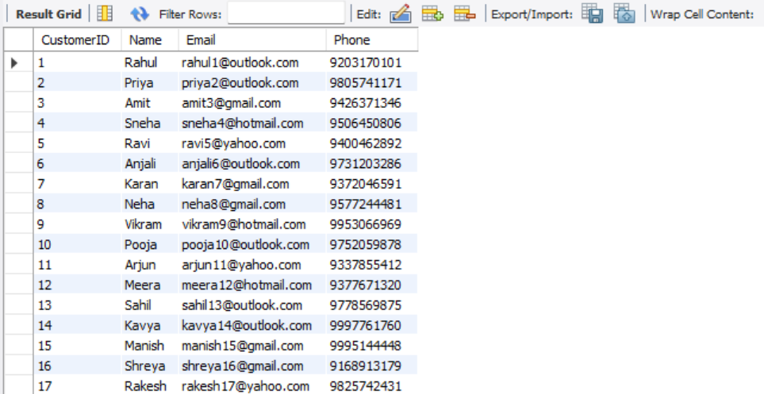

Problem Statement: - It is necessary to provide users and administrators with a catalog of movies available for booking. Each movie contains details such as its title, genre, and rating. The genre (e.g., Action, Comedy, Drama, Animation) allows customers to filter movies based on their interests, while the rating (U, UA, A) ensures that age-appropriate restrictions are clear.
Q2. List all movies with their genre and rating
SELECT Title, Genre, Rating FROM Movies;
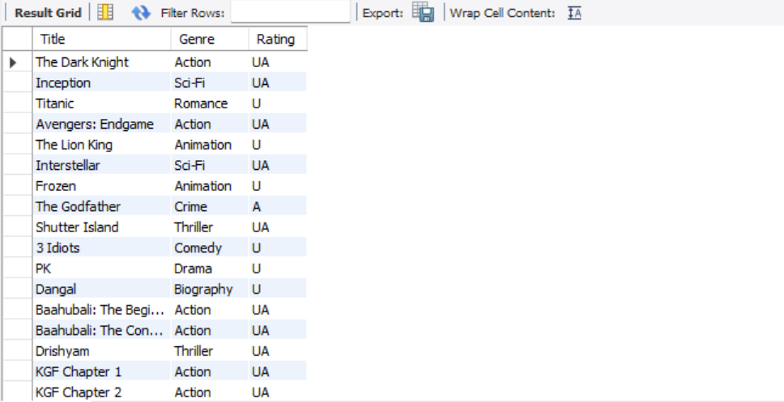
Problem Statement: - In the Movie Ticket Booking System, theatres are spread across different cities. Customers often search for shows available in their city. This query retrieves a list of all theatres located in a specific city, such as Mumbai.
Q3. List all theatres in a specific city (e.g., Mumbai)
SELECT * FROM Theatres WHERE Location = 'Mumbai';
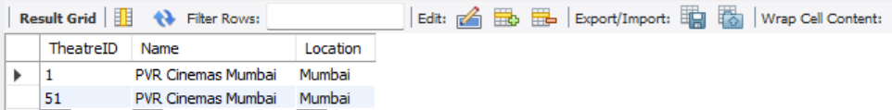

Problem Statement: - Each movie in the booking system is scheduled for multiple shows across different theatres, dates, and times. Customers often want to know all available shows for a particular movie before booking. This query retrieves all shows of a specific movie (for example, MovieID = 1) along with important details such as the theatre, show date, and show time.
Q4. List all shows for a specific movie (e.g., MovieID = 1)
SELECT s.ShowID, m.Title, t.Name AS Theatre, s.ShowDate, s.ShowTime
FROM Shows s
JOIN Movies m ON s.MovieID = m.MovieID
JOIN Theatres t ON s.TheatreID = t.TheatreID
WHERE s.MovieID = 1;
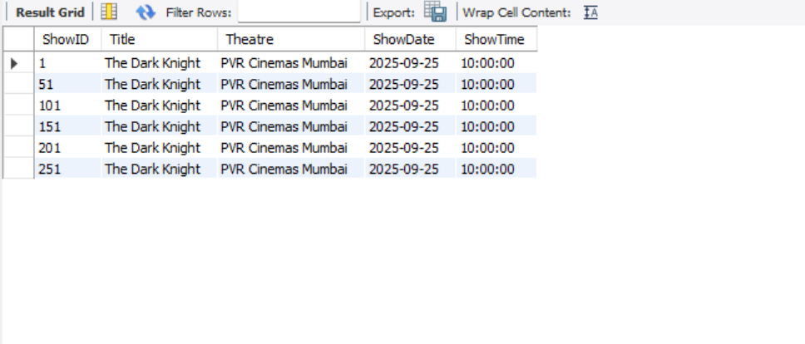

Problem Statement: - Customers may book multiple tickets for different movies and shows over time. To manage or review their booking history, the system should allow fetching all bookings made by a specific customer. This query retrieves all bookings for a given CustomerID (e.g., CustomerID = 1).
Q5. List all bookings of a particular customer (e.g., CustomerID = 1)
SELECT b.BookingID, m.Title, t.Name AS Theatre, s.ShowDate, s.ShowTime, b.SeatsBooked
FROM Bookings b
JOIN Shows s ON b.ShowID = s.ShowID
JOIN Movies m ON s.MovieID = m.MovieID
JOIN Theatres t ON s.TheatreID = t.TheatreID
WHERE b.CustomerID = 1;
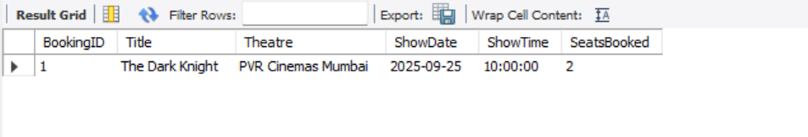

Problem Statement: - Each show in the Movie Ticket Booking System can have multiple customers booking tickets. To analyze how well a show is performing, administrators often need to know the total number of seats booked per show. This query calculates the sum of seats booked for every show by aggregating booking data.
6. Total seats booked for each show
SELECT ShowID, SUM(SeatsBooked) AS TotalSeatsBooked
FROM Bookings
GROUP BY ShowID
ORDER BY TotalSeatsBooked DESC;
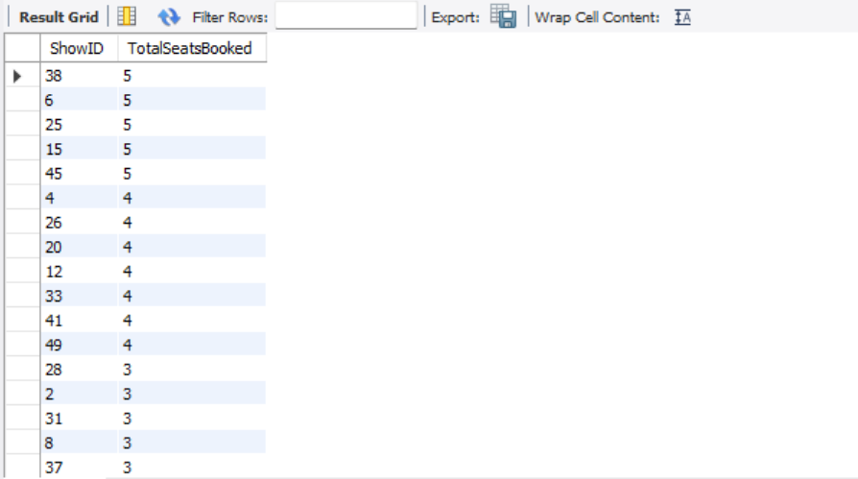

Problem Statement: - In the Movie Ticket Booking System, customers may make multiple bookings over time. To track customer activity, the system should be able to calculate how many bookings each customer has made. This query retrieves the total number of bookings per customer by counting their booking records.
7. Total bookings per customer
SELECT CustomerID, COUNT(*) AS TotalBookings, SUM(SeatsBooked) AS SeatsBooked
FROM Bookings
GROUP BY CustomerID
ORDER BY TotalBookings DESC;
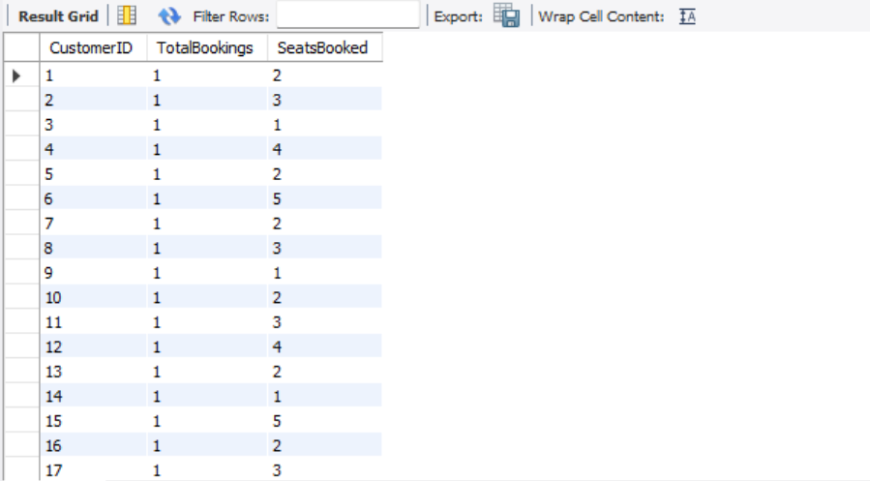

Problem Statement: - In a Movie Ticket Booking System, some movies attract more audience than others. To measure a movie’s popularity, we can calculate the total number of seats booked across all its shows. The movie with the highest number of seats booked is considered the most popular movie.
Q8. Most popular movie (by total seats booked)
SELECT m.Title, SUM(b.SeatsBooked) AS TotalSeats
FROM Bookings b
JOIN Shows s ON b.ShowID = s.ShowID
JOIN Movies m ON s.MovieID = m.MovieID
GROUP BY m.MovieID
ORDER BY TotalSeats DESC
LIMIT 1;
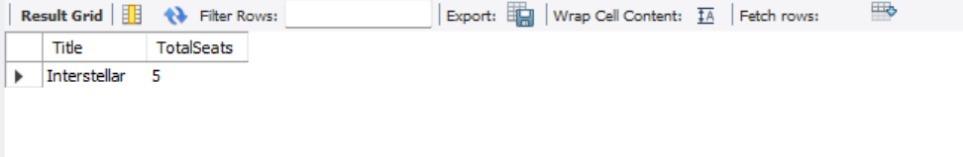

Problem Statement: - The Movie Ticket Booking System maintains show timings for different movies across theatres. Customers may want to check which movies are playing on a specific date so they can plan their visit. This query retrieves all shows that are scheduled for a given date (for example, 2025-09-25).
Q9. Shows scheduled on a particular date (e.g., '2025-09-25')
SELECT s.ShowID, m.Title, t.Name AS Theatre, s.ShowTime
FROM Shows s
JOIN Movies m ON s.MovieID = m.MovieID
JOIN Theatres t ON s.TheatreID = t.TheatreID
WHERE s.ShowDate = '2025-09-25';
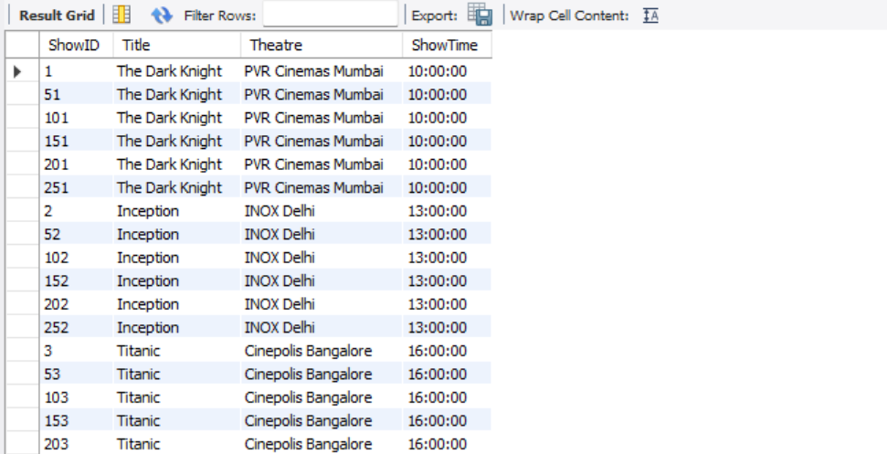
Problem Statement: - The Movie Ticket Booking System schedules multiple shows across different theatres. To manage theatre utilization and plan schedules efficiently, administrators need to know how many shows are scheduled in each theatre. This query calculates the total number of shows for every theatre.
10. Number of shows per theatre
SELECT t.Name AS Theatre, COUNT(*) AS TotalShows
FROM Shows s
JOIN Theatres t ON s.TheatreID = t.TheatreID
GROUP BY t.TheatreID
ORDER BY TotalShows DESC;
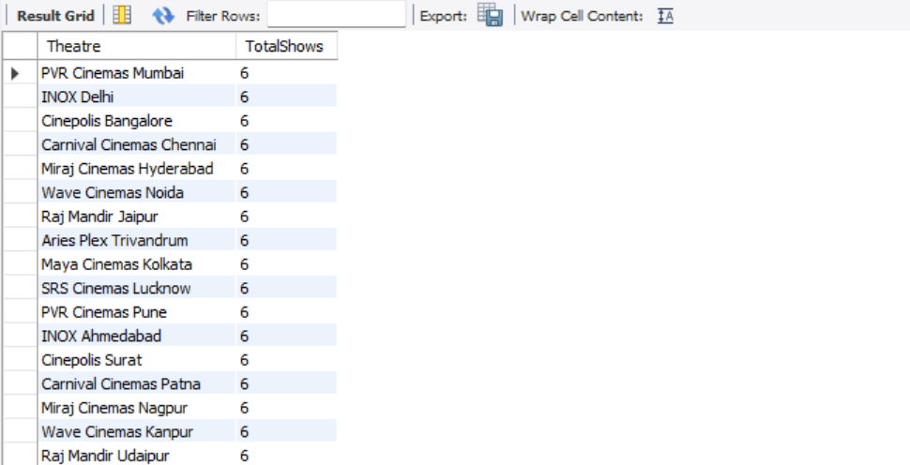

Problem Statement: - In the Movie Ticket Booking System, multiple shows are scheduled in different theatres, and each show can have multiple bookings. To analyze theatre performance and popularity, it is important to calculate the total number of seats booked per theatre. This query sums up the seats booked across all shows in each theatre.
11. Total bookings per theatre
SELECT t.Name AS Theatre, SUM(b.SeatsBooked) AS TotalSeatsBooked
FROM Bookings b
JOIN Shows s ON b.ShowID = s.ShowID
JOIN Theatres t ON s.TheatreID = t.TheatreID
GROUP BY t.TheatreID
ORDER BY TotalSeatsBooked DESC;
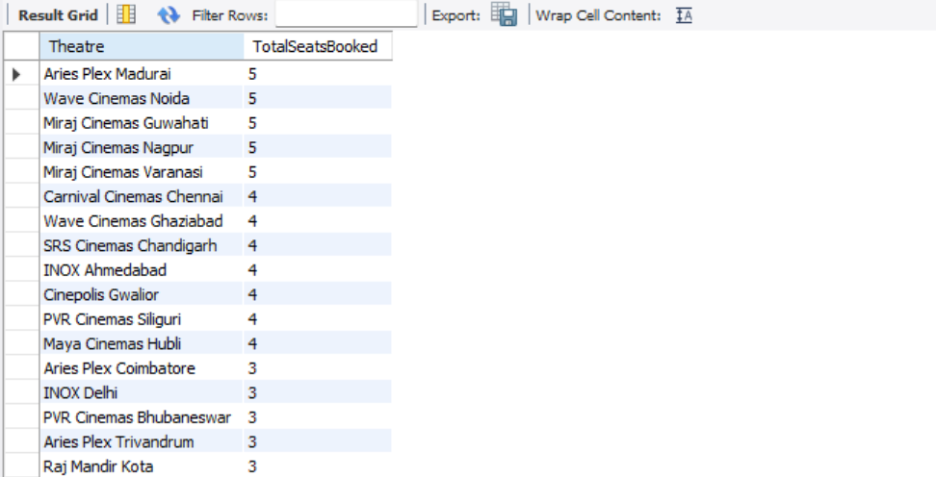

Problem Statement: - Customers often want to check which shows they have booked that are scheduled for the future. This query retrieves all upcoming shows for a specific customer (e.g., CustomerID = 1) by filtering bookings based on the ShowDate.
12. Upcoming shows for a specific customer
SELECT b.BookingID, m.Title, t.Name AS Theatre, s.ShowDate, s.ShowTime
FROM Bookings b
JOIN Shows s ON b.ShowID = s.ShowID
JOIN Movies m ON s.MovieID = m.MovieID
JOIN Theatres t ON s.TheatreID = t.TheatreID
WHERE b.CustomerID = 1 AND s.ShowDate >= CURDATE();
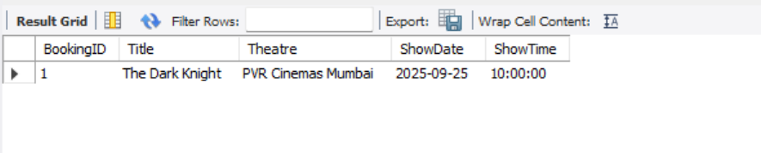
Problem Statement: - In a Movie Ticket Booking System, it is important for administrators to identify movies that have not received any bookings. This can help in analyzing customer preferences, planning promotions, or adjusting show schedules.
13. Movies with no bookings
SELECT m.MovieID, m.Title
FROM Movies m
LEFT JOIN Shows s ON m.MovieID = s.MovieID
LEFT JOIN Bookings b ON s.ShowID = b.ShowID
WHERE b.BookingID IS NULL;
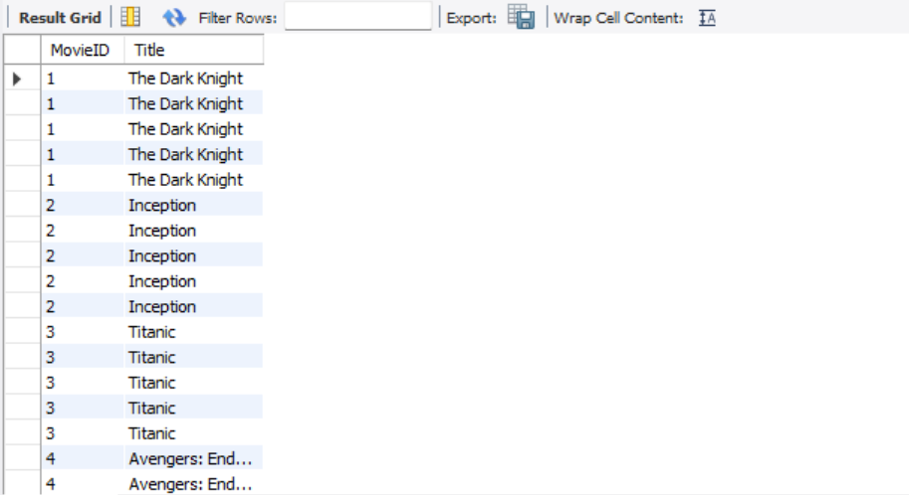

Problem Statement: - In a Movie Ticket Booking System, it is useful to track how many seats have been booked for each movie to understand movie popularity and audience engagement. This query calculates the total number of seats booked for every movie by aggregating booking data across all its shows.
14. Total seats booked per movie
SELECT m.Title, SUM(b.SeatsBooked) AS TotalSeatsBooked
FROM Bookings b
JOIN Shows s ON b.ShowID = s.ShowID
JOIN Movies m ON s.MovieID = m.MovieID
GROUP BY m.MovieID
ORDER BY TotalSeatsBooked DESC;

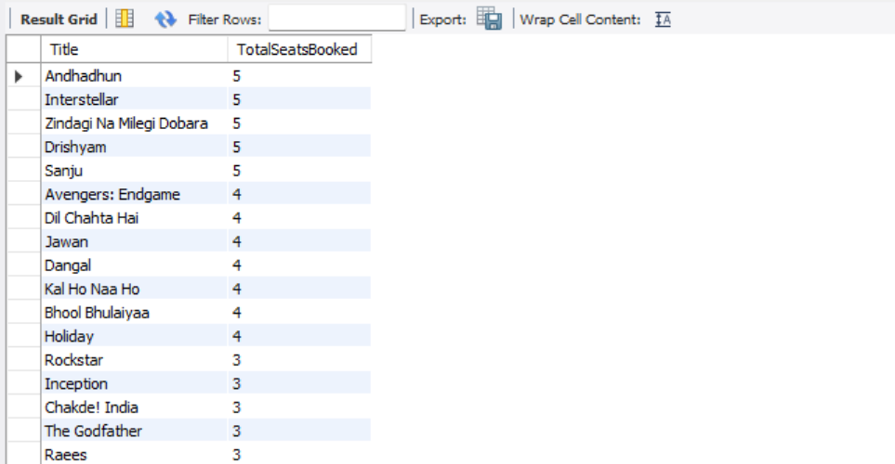

Problem Statement: - In the Movie Ticket Booking System, some customers may book multiple seats in one booking for family or group outings. This query identifies customers who have booked more than 3 seats in a single transaction.
15. Customers who booked more than 3 seats in a single booking
SELECT c.Name, b.BookingID, b.SeatsBooked
FROM Bookings b
JOIN Customers c ON b.CustomerID = c.CustomerID
WHERE b.SeatsBooked > 3
ORDER BY b.SeatsBooked DESC;

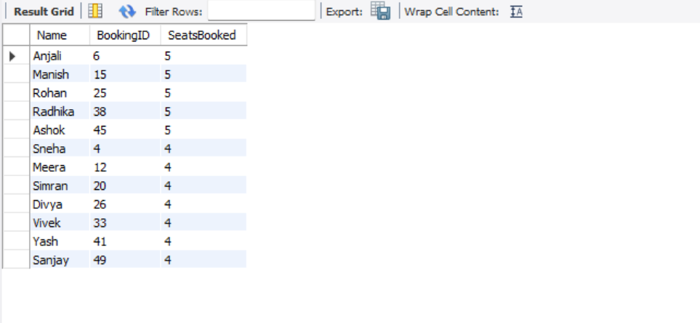
Conclusion: - The Movie Ticket Booking System provides an efficient way to manage movie schedules, theatre details, customer information, and ticket bookings. By using SQL databases, the system ensures that large volumes of data—such as customers, movies, shows, and bookings—are stored securely and can be retrieved quickly when needed.

